HyperEuclideanSet

HyperEuclidean MIDI Generator

User Manual

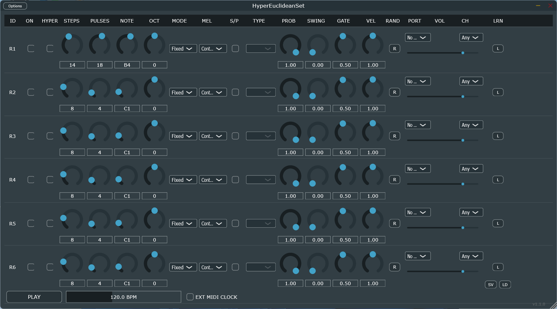

1. Overview
HyperEuclidean MIDI Generator is a 6-track algorithmic sequencer based on Euclidean rhythm geometry. Instead of traditional step-by-step programming, you define the "density" of notes within a time space, allowing for the creation of complex polyrhythms and generative melodies in seconds.

2. Track Controls (The Channel Strip)
Each of the 6 rows functions as an independent generator. Moving from left to right, the user can configure:

A. Core Logic & Activation
- ON (Toggle): Enables or disables MIDI generation for the specific row.
- HYPER (Toggle): * Off: Uses standard Euclidean distribution (Bjorklund algorithm).
  - On: Activates the Hyper-Euclidean mode, distributing pulses across multiple "depth" layers for irregular, organic patterns.
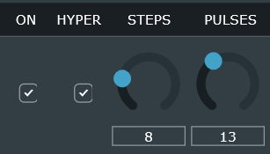 | 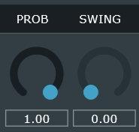

B. Rhythmic Shaping
- STEPS (Slider 1-64): The total length of the sequence cycle.
- PULSES (Slider 1-64): The number of notes (beats) to be distributed within the Steps.
- SWING (Slider 0-100%): Offsets even-numbered steps to create a "groove" or "human feel."
- PROB (Slider 0-100%): The probability that a programmed pulse will actually play. Choice: Set to 100% for mathematical precision, or lower for evolving, unpredictable patterns.
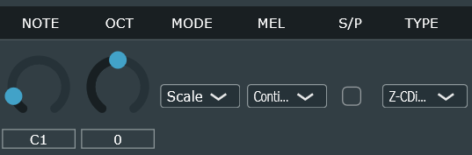

C. Melodic & Pitch Selection
NOTE (Slider/Value): The root MIDI note (e.g., C3).
OCT (Slider -1 to +4): Real-time octave shifting.
MODE (Dropdown Menu):
Fixed: Always plays the root MIDI note.
Input: Follows external MIDI notes (MIDI Learn/Follow).
Scale: Generates notes based on a selected musical scale.
Chord: Generates notes based on specific chord intervals.
TYPE (Dropdown Menu): Dynamically populates based on the Mode. Choice: Select from dozens of presets (e.g., Z-DMixolydian, PentaMinor, Cmaj7-Jazz, etc.).
MEL (Dropdown Menu):
Continuum: The melodic index advances indefinitely regardless of rhythm length.
Looped: The melody resets its position whenever the Euclidean cycle restarts.
S/P (Step/Pulse Toggle):
Inactive: Melody advances on every Step (silent steps still move the melody forward).
Active: Melody advances only on a Pulse (the sequence only moves when a note is triggered).

D. Performance & Output
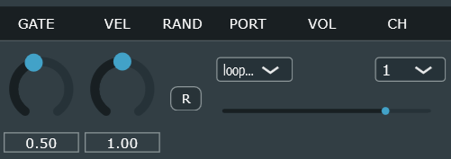

- GATE (Slider 0-100%): Controls note duration. Choice: Low values for staccato, high values for legato.
- VEL (Slider 0.0 - 2.0): Velocity multiplier. It scales the internal velocity (base 80 / accent 120) to match your synth's sensitivity.
- RAND (Button): Instantly randomizes all parameters for the row—ideal for "happy accidents."
- PORT (Standalone only): Selects the physical or virtual MIDI output (e.g., loopMIDI, USB MIDI Interface).
- VOL (Slider 0-127): Sends MIDI CC7 (Main Volume) to the receiving instrument.
- CH (Dropdown 1-16): Sets the specific MIDI channel for the row.

3. Global Controls (Footer)
- PLAY/STOP: Starts/Stops the internal sequencer (Standalone mode).
- BPM: Sets the tempo (40 - 240 BPM).
- EXT MIDI CLOCK (Toggle):
* Off: Uses the internal BPM slider.
* On: Syncs automatically to your DAW (VST3) or external hardware clock.

4. MIDI Learn System (LRN Column)
Each sequencer row (R1-R6) now has an independent MIDI mapping system, allowing you to control parameters via external hardware controllers (knobs, faders, pads).
How to map a parameter:
1. Activation: Click the "L" button in the last column to the right of the desired row.
2. Selection: A drop-down menu will appear. Select the parameter you wish to map (e.g., Steps, Notes, Probability, Volume).
3. Listening: Once selected, the "L" button will turn red and display a question mark "?". The plugin is now in "listening" mode.
4. Assignment: Move the knob or fader on your physical controller. The plugin will detect the MIDI CC signal and instantly assign it to the selected parameter.
5. Confirmation: The button will return to its original color and display the letter "L" again.
Note: In the drop-down menu, parameters already mapped will display the assigned CC number in square brackets (e.g., Steps [CC 74]).

Clearing Mappings:
• To remove all mappings from a single row, open the "L" menu and select "Clear All Mappings".

Saving and Loading Maps (.json)
The ability to export and import MIDI Learn configurations has been introduced. This is useful for creating different "templates" for different controllers.
• SV (Save) button: Opens an operating system dialog to save the current configuration of all CCs to a .json file.
• LD (Load) button: Loads a previously saved .json file, instantly restoring all MIDI mappings on all 6 rows.
Positioning: These buttons are located at the bottom right of the interface, aligned vertically under the LRN column.

5. MIDI Port and Channel Management
Routing options have been enhanced for greater flexibility between the Studio (VST/AU) and Live (Standalone) environments.
Channel Selection (CH Column)
Each row can now transmit on a specific MIDI channel (1-16) or in "Any" mode (transmits on the global channel). This allows you to control up to six different synthesizers or instruments simultaneously with a single instance of the plugin.
Port Selection (Standalone Only - PORT Column)
In the Standalone version, above the volume slider for each row, there is a drop-down menu to select the physical MIDI output port.
• You can send row 1 to a hardware MIDI interface and row 2 to an internal virtual generator.
• Dynamic Refresh: The port list updates automatically every time you click the menu, allowing you
to connect new devices without restarting the application.

Quick Start Guide: Three Creative Examples

1. Techno Bassline (Hypnotic & Driving)
For a bassline that pushes forward without ever fatiguing the listener:
- STEPS: 16 | PULSES: 7
- NOTE: E1 | OCT: 0
- MODE: Fixed
- GATE: 30% (for a tight, rhythmic sound)
- VEL: 1.2 (to give the synth more "punch")
- Pro Tip: Enable HYPER to slightly shift the accents, making the bass feel less static and more organic.

2. Ambient Polyrhythm (Ethereal & Generative)
To create textures that feel like they never repeat, use two rows with different cycle lengths:
- Row 1: STEPS: 15 | PULSES: 4 | NOTE: C4 | MODE: Scale (PentaMinor)
- Row 2: STEPS: 22 | PULSES: 5 | NOTE: G4 | MODE: Scale (PentaMinor)
- MEL: Continuum | S/P: Active
- GATE: 80% (for long, dreamy notes)
- The Result: Because 15 and 22 have different mathematical cycles, the two melodies will cross paths in ever-changing ways.

3. Jazz Chord Generator (Complex Harmony)
To generate jazzy progressions to feed into an electric piano or synth:
- STEPS: 16 | PULSES: 4
- MODE: Chord | TYPE: Am7-Jazz or Cmaj7-Jazz
- MEL: Looped (so the chord resets at the beginning of every measure)
- SWING: 60% (for that classic "shuffled" jazz feel)
- RAND: Hit the "R" button occasionally to shuffle the order of the notes within the chord.

Troubleshooting

1. No sound is produced
- Check MIDI Port: In Standalone mode, ensure the PORT column is not set to "No Out." Select a physical interface or a virtual driver like loopMIDI.
- MIDI Channel: Verify that the channel set in the CH column matches your instrument's input channel (e.g., if the plugin transmits on CH 1, the synth must receive on CH 1 or Omni).
- VOL Slider: Make sure the horizontal volume slider for that specific row is turned up.
- PLAY Status: In Standalone mode, the PLAY button in the footer must be toggled on (green color).

2. Sequencer is not starting or out of sync
- External Clock: If EXT MIDI CLOCK is enabled, the sequencer will wait for a Start signal from your DAW. If you are using the Standalone app without an external clock, turn this option off.
- Steps/Pulses: If PULSES is set to 0, no notes will be generated for that row.

3. Stuck or "Hanging" notes
- Gate Settings: If the GATE value is set too high, notes might overlap and stay on. Try reducing the Gate length.
- Reset: Toggle the PLAY button off and on to clear the MIDI buffer and send an "All Notes Off" command.

4. Why don't I see the "PORT" selector in my VST3?
In plugins, physical port management is delegated to the DAW (Ableton, Cubase,
etc.). The plugin sends MIDI to the track bus, and the DAW routes it to the desired
port.

5. The SV and LD buttons don't appear immediately.
Make sure you've installed the latest update. If the problem persists, resize the window slightly
by dragging the bottom-right corner to force the components to refresh.

Technical Specifications

Software Architecture
- Framework: Built with JUCE 8 (C++).
- Parameter Management: Utilizes AudioProcessorValueTreeState for thread-safe communication and full DAW automation support.
- Timing: Sample-accurate MIDI triggering processed within the processBlock loop, ensuring zero jitter even at high BPMs.

Mathematical Core
The engine uses a modified version of the Bjorklund Algorithm, originally designed for neutron accelerators and later adapted for ethnomusicology. The algorithm ensures that pulses are distributed as evenly as possible among steps, creating the "maximum evenness" characteristic of traditional world rhythms.
E(k, n) = {n}{k} “0" - on-liner (stateless) version: pulse (i) = (((p . (i + r)) (mod n)) + p) > n
Notes are generated in the processBlock with sample-level precision to avoid rhythmic jitter.

UI Rendering
The interface uses Direct2D (on Windows) for hardware-accelerated graphics. Custom textFromValueFunction lambdas are used to translate raw MIDI data into human-readable musical notation (e.g., Note 60 $\rightarrow$ "C3") in real-time.

Memory Management
The system uses std::unique_ptr and juce::OwnedArray to prevent memory leaks. Leak messages detected during debugging are often related to the delayed destruction of Windows font descriptors, but they do not affect the plugin's runtime stability.

INDEX

1. Overview ………………………….………………. pag. 1
2. Track Controls ……………………...……………. pag. 2
3. Global Controls …………..………………………. pag. 3
4. MIDI Learn System ………...…………………….. pag. 4
5. MIDI Outpus Management ………..…………….. pag. 5
6. Quick Start Guide: 3 Creative Examples …….... pag. 6
7. Troubleshooting …………………………..………. pag. 7

8. Technical Specifications …………………………. pag. 8

